Deal Lake Master Plan - 2016

A Plan of Action for Deal Lake, Monmouth County, NJ

Prepared by the Deal Lake Commission
(Living Draft – started in 2012 as of 2/18/2016

Deal Lake Commission
Interlaken Town Hall
100 Grasmere Ave
Interlaken, NJ 07712

Jessie Joseph – Commission Clerk

www.DealLake.org

Commission Members for 2012:

Allenhurst Borough – Bruce Fromer, Treasurer
City of Asbury Park – Susan Henderson
Borough of Deal – Jim Rogers, Vice Chairman
Interlaken – Rick Guibord
Neptune Township – Jason Jones
Ocean Township – John Everson
Village of Loch Arbour – Erin Dolan

Commission Members for 2016:

Don Brockel, Ocean, Chairman
Don Nissim, Interlaken, Vice-Chairman
Sue Henderson, Asbury Park
Bruce Fromer, Allenhurst, Treasurer
Erin Dolan, Loch Arbour, Secretary
Eric Houghtaling, Neptune, Assistant Treasurer
Elliot Chera, Deal
Staff
Commission Clerk – Jessie Joseph
Environmental Consultant – Dr. Stephen Souza, Princeton Hydro, LLC.
Engineer – Peter Avakian, Leon S. Avakian, Inc.
Attorney – Hunt Parry, Esq.
Web Master – Sam Hartung
CFO: Lorraine Carafa

Professionals:

Environmental Consultant – Dr. Stephen Souza, Princeton Hydro, LLC.
Engineer – Peter Avakian, Leon S. Avakian, Inc.
Attorney – Hunt Parry, Esq.
Web Master – Sam Hartung

PURPOSE OF PLAN

This plan focuses on solving the problems of Deal Lake, its tributaries, and its 4400 acre watershed. This plan will be as much instructive and educational as it will be a road map for future projects.

For decades Federal and State governments along with environmental groups have focused on cleaning the coastal waters of the Atlantic Ocean. These efforts have significantly improved ocean water quality and given us cleaner beaches. When we look at current sources of ocean pollution, we realize little attention and money has been given to restore and safe guard our rivers, bays, estuaries, and coastal lakes. These inland waterways are now the primary sources of pollution entering the ocean.

The plan brings attention to the problems of Deal Lake and offers solutions to improve the lake’s quality.

BACKGROUND
.
Deal Lake’s watershed is over 4400 acres in size. Most of the watershed is developed and comes under the category as being an ‘urban watershed’. Currently, stormwater enters over 4000 storm drain inlets located in seven municipalities and travels through a network of pipes emerging via 250 outfalls that deliver this runoff into a tributary or directly into the lake.

Needs work!!
As is the case with many of New Jersey’s coastal lakes, there have been limited funds to manage runoff, over the years to manage runoff prior to its release into Deal Lake or its tributaries. But we have had great successes recently as in our Comstock Ave Manand Colonial Golf Couse improvement project But much more is required. The existing storm water infrastructure system in fact uses the lake as the primary regional means of flood attenuation. Given that there has historically been little done to address stormwater pollutant loading, the lake also serves as the sole means of passive pollutant removal prior to discharge into the ocean. If an improvement is not achieved in the overall management of stormwater, the lake’s water quality will never improve.

Over 98% of our watershed is not covered by any form of stormwater basins. Most of Deal Lake’s problems are rooted in the lack of stormwater controls in the watershed. In essence, Deal Lake has been reduced over the years to a 157e stormwater basin.

Due to the magnitude and widespread nature of these problems, improvements in the water quality and ecology of the lake cannot be fully realized without the following:

- Regional storm water management solutions that correct, replace and/or retrofit the existing stormwater management infrastructure;
- Stabilization of the lake’s stream channels;
- Control of the influx of pollutants, including floatables;
- Better stormwater management planning and design, with the focus placed on stormwater recharge to help moderate base flows, decrease storm surges and flooding and lessen the opportunity for streambed and bank scouring;
- Upgrade and retrofit of the existing stormwater management infrastructure and use of these opportunities to address and correct localized stormwater and pollutant loading problems;
- Reclamation of sediment-in-filled areas of the lake and development of a long-term management plan to ensure that the factors responsible for the infilling are corrected and that the reclaimed areas are easily and effectively maintained over time;
- Decrease in the occurrence of invasive species within the lake and within the riparian areas of the lake and its tributaries;
- Decrease in the frequency and magnitude of algae blooms;
Improvement in the lake’s fishery as a major means of improving the lake’s overall use attainment; and decrease in fecal coliform loading.
- Storm baffle system built within our flume channel to allow flow out and restricts Ocean surge during major north easterlies and hurricanes storms.
- Increase enforcement of public and private leaf and debris dumping.
- Increase public awareness of how they can help Deal Lake with litter/debris removal and the ills of dumping.
- Increase pressure on public officials to fund projects to improve Deal Lake.

TOPOGRAPHY AND MAP

Due to a series of dams and geographically isolated sections in the main body, Deal Lake can be divided into eleven distinct ecosystems (twelve, if Sunset Lake is counted), each with its own set of problems. There are also seven significant streams that feed into the lake. Focusing on a section at a time will allow us to better fund maintenance and restoration projects and make these efforts more manageable. Here are the sections and stream tributaries:

Lake Sections and Ponds:

- Ocean section – East of Railroad Bridge to Ocean Avenue
- Main section – East of Wanamassa Point to Railroad Bridge
- Allenhurst section – West of Railroad Bridge to Monmouth Road
- Ironwell section – Just West of Allenhurst section and North of Interlaken
- Martin’s Branch – South of Interlaken and North of Wanamassa Point
- Sunset section – West of Wanamassa Point to Wickapecko Road
- Fireman’s Pond – Just West of Wickapecko Road between Grassmere and Raymere Avenues
- Lollipop Pond – West of Wickapecko Road and North of Foodtown Liquors
- Lollipop Retention Basin – West of Lollipop Pond
- Terrace Pond – West of Wickapecko Road and North of Colonial Terrace
- Hollow Pond – West of Wickapecko Road and South of Colonial Terrace
- Sunset Lake – (Not part of, but drains into Deal Lake) WE sure about that? It sure seems to be part of Deal lake. Between Sunset and 5th Avenues I think we should add it…

Significant Streams (From North to South):
- Harvey Brook (formerly Hog Swamp Brook) Headwaters at Kepwel Spring in Wayside
- Ironwell Creek (just south of Corlies ave and north of Interlaken park)
- Un-named Stream (feeds Fireman’s Pond)
- Un-named Stream (feeds Lollipop Pond)
- Un-named Stream (feeds Terrace Pond via English Manor)
- Un-named Stream (feeds Terrace Pond via Seaview Mall) (Headwaters un-named pond on Route 66.)
- Hollow Brook (Headwaters in West Bangs Avenue sand hills section in Neptune; runs south of ShopRite and Shore Lanes bowling lanes)
DEAL LAKE MAP

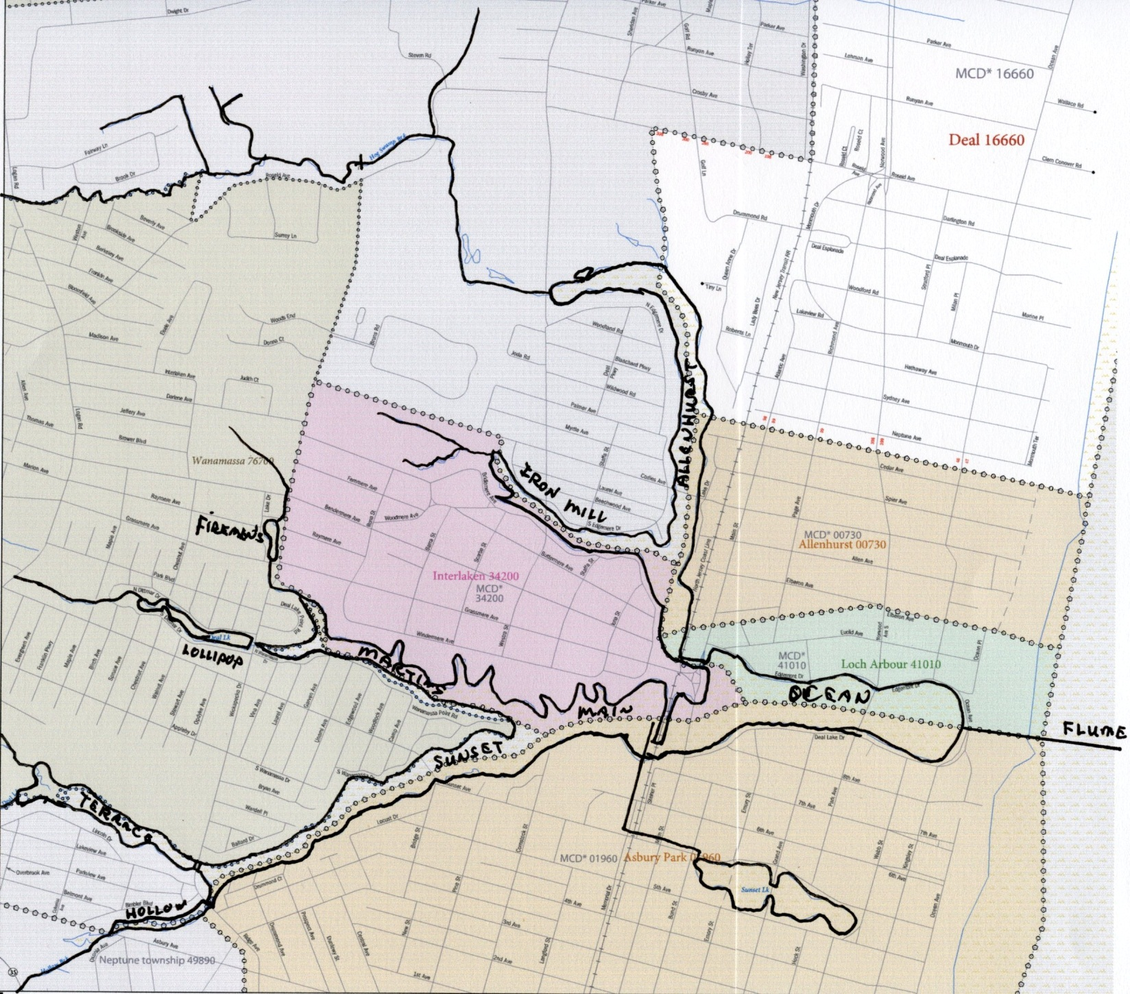
Map of Deal Lake

LAKE CHARACTERIZATION SPREADSHEET

This page(s) will contain a spreadsheet broken down by lake sections as defined above and will characterize each section by size, shoreline, water depth, etc. and by identifying problems such as: weeds, algae, pollutant levels, fallen trees, approximate amounts of organics and dredge spoils, access, etc.
MASTER PLAN HIGHLIGHTS – Important Issues

DEP Restrictions and Permitting Issues – The ability to do restoration projects on the lake and its tributaries is highly regulated. Permits for such work as dredging, stream restoration, shoreline and bank stabilization, and maintenance/repair of various flow control structures require NJDEP, and at times Army Corp of Engineers, permits. Overall, to decrease regulation driven constraints we need a more receptive regulatory review process. This can be accomplished by:
- Have the DEP handle public governments and commissions differently from private developers. The DEP should partner with local authorities to remediate environmental problems.
- Allow public governments and commissions to receive “blanket permits” for all small maintenance projects that we can complete through partnering with public works departments at the local and county levels.
- Streamline the permit process for dredging, stream bank repair and related environmentally beneficial projects.
- Minimize or eliminate any permit fees for environmentally beneficial projects.

Dredge Material Disposal Solution – The lack of a permanent regional solution for the material and sediments removed from Deal Lake is one of the Commission’s largest obstacles to completing hydro-raking and dredging projects. Even with the limited funding available to the Commission, we can move forward with small maintenance projects by partnering with local municipal and county public works departments. However, the lack of pre-defined, NJDEP approved disposal sites we often are unable to implement these projects. The Commission strongly supports the creation of a task force to create find a permanent solution to dredge and hydro rake materials disposal (including when possible the beneficial reuse of the material) One possible idea way to accomplish this is for Monmouth County to purchase an abandoned sand and gravel mine to use as a disposal site and recycling center for the sediment and organic material removed from the lake. Once proven clean, this material could be mixed with leaf mulch and sand to create usable soil for sale to the public.
In the meantime the Commission will continue to pursue partnering with the County as part of their fast-track dredging projects.

Storm Water Management – The Deal Lake watershed is about 85% developed. With every significant rain event most storm water is drained directly into the lake and its streams causing rapid rising of lake levels. Less than 1% of the developed areas hold storm water in effective detention basins that allow for the slow release of the storm water let alone enabling recharge of the aquifers. Our plan would:
- Identify locations on both public and private property where large regional storm water bio-detention basins could be constructed in the future.
- Permanently set aside this land for future basin use.
- Restore impacted the impacted riparian corridors and floodplains of the lake’s tributaries. Doing so provides a natural means of collecting and storing stormwater. This not only reduces flooding, but it also decreases the erosive forces that continually down cut and erode the streams’ bed and banks (one of the major sources of sediment loading to the lake).
- Encourage the partnership of public officials and commercial property owners to construct regional storm water basins and re-pipe storm drains into them.
- Remove legal obstacles by having legislation created that would provide tax relief to private land owners who participated.
- Refurbish Mayer Dam, located within Harvey Brook off Roseld Avenue at Wickapecko Avenue, to restore a large on-line storm water retention basin.
- Work with county Bridge department and other government agencies to rebuild various Wickapecko bridges and add flood control devices and dredging the water body above the bridge. Fish latters to be added as in recently rebuilt Hollow Brook Bridge. Create several regional storm water management basins in the vicinity of Sea view Square Mall and the Asbury Park (Rte 35/66) traffic circle.

Storm Drain Issues - Litter, Fertilizer, And Animal Waste – Current storm water regulations require local municipalities to clean all storm drain basins annually. Regulations also require municipalities to upgrade drain heads with new ‘eco-design’ grates whenever a street is repaved or constructed. We would like to:
- Do an assessment of existing old-style drain heads and determine which ones allow the most floatables and debris into the lake. (Apply the 80 / 20 rule.)
- Seek state funding to speed up the installation of the prioritized drain basins by the towns, county and state DOT.
- Work with local municipalities to keep the new drain heads debris free and prevent street flooding from the grates becoming clogged.
- Continue to seek Section 319h funds for the installation of large MTD’s where applicable.
- Ensure towns do in fact install “eco-designed” grates during road construction.

MASTER PLAN HIGHLIGHTS – Projects

Flooding – A major responsibility of the Commission is to minimize the risk of flooding from significant rain events by coordinating the opening and closing the flume gates. Projects that will help minimize this risk include the following:
- Electrification of the flume gate mechanisms and maintaining manual operation to ensure operation during times of power outage. .(ongoing project with the ACOE)
- .
- The refurbishment of Mayer Dam located in Harvey Brook off Roseld Avenue at Wickapecko Avenue to create a large in-stream storm water retention basin.
- Create several regional storm water management basins in the vicinity of Sea view Square Mall and the Asbury Park (Rte 35/66) traffic circle and ensure the Coke Plant property is storm water friendly and meets and exceeds state requirements.
- Annually remind the towns and their planning boards of storm water management requirements.

Removal of Organics, Debris, and Fallen Trees (Hydro-raking) – The Commission has budged for continued Hydro-raking of various lake sections as demonstrated by a pilot project recently completed (2011-12) of the Lollipop regional storm water basin during. Hydro-raking is not dredging as it does not involved the removal of accumulated silt. However, it has some advantages relative to dredging:
- Currently does not require any DEP permits.
- Allows for the removal of all organics, debris, and even fallen trees.
- The disposal of this debris and organics (though still difficult) is easier and less expensive then disposing of dredged sediments.
- In some areas of the lake 1 to 2 feet of depth can be restored by removing the accumulated debris.

Dredging – Every section of Deal Lake needs dredging. Dredging is the part of the ultimate solution to restoring the lake and improving its water quality and ecological functionality. Challenges related to dredging are the following:
- A safe, local dredge spoil disposal site does not exist.
- It is costly. If the sediments are contaminant free it costs about $40 - $50 per cubic yard (approximately a ton of wet sediment) if a private contractor is used to dredge and dispose of sediment. If the sediments contain elevated levels of contaminants the cost skyrockets to $85-$110 per cubic yard. In fact costs of removal of sandy material in dec 2015 were about $138/Cu yard.
- Due to the developed nature of the watershed, most sections of Deal Lake lack sufficient adjacent de-watering sites. This adds to the complexity of a dredging operation in that unless the sediments are sufficiently dewatered it costs dredging costs can escalate due to all of the added water weight. Additionally, disposal sites may not accept sediments that are not at least partially dewatered and it may be a permit violation to truck the material unless it has at been partially dewatered. Dewatering sites may have to found within the lake boarders.
- Volume of storm water entering the Western sections must be drastically reduced. As noted above, bed and bank erosion of the tributaries is a or silt will continue to migrate into Deal Lake requiring frequent maintenance dredging.
- Transporting dredged material requires special water tight vehicles to prevent spillage onto public roads. Possible alternatives are tanker trucks and open top dry bulk trucks.
- Ideally the removal of accumulated silt will begin in the western portions of the lake and then proceed to the east and include the lake’s main body. As part of the dredging efforts of the western arms and attempt will be made to increase their flood control, sediment containment and nutrient removal capabilities. To increase the longevity of these projects it is imperative that future sediment loading be reduced. This again will require more aggressive stormwater management.
- Dec 2015 the DLC completed removal of about 13,000 Cu yards of sandy sediment on the eastern end of the lake with $1.6 Million NRCS /DEP Grant. That still leaves about 150,000 cubic yards of dredging of the Eastern section (east of the RR tracks) that was filled in by Sandy. Further government support is required to achieve complete the project that was designed and submitted to the DEP and NRCS.

Water Quality – Several less expensive projects can help with improving water quality. The Commission has been able to perform some of these projects as a result of the increased funding we received in 2007. These projects include:
- Installation of permanent testing equipment at strategic locations.
- Weed herbicide treatments where needed.
- Weed Harvesting where needed

Lake Bank Stabilization and Aesthetics – Most of Deal Lake’s 27 mile natural shoreline has become overgrown with invasive, non-native vegetation. Some of the more pervasive weeds are knotweed, common reed, and purple loosestrife. These plants overgrow the more desirable native species, and often compromise the stability of the lake’s shoreline and stream banks. Both public and private shorelines have been neglected and now are overgrown with excessive trees, weeds and invasive plants. The remaining shoreline in the Eastern main lake section along the Asbury Park, Loch Arbour and Interlaken shorelines have had bulkheads installed. Projects:
- Loch Arbour’s concrete bulkhead was replaced in 2000 & 2004 and the final section fully replaced in 2011. Asbury Park’s sections of bulkhead continue to weaken and fall into the lake. Replacing the remaining potions of Asbury Park’s aged bulkhead is a high priority.
- Invasive and non-native vegetation growth in and on the “ocean section” bulkhead is a problem and will require annual herbicide treatments and/or physical removal to control.
- Educate lakeside property owners the correct techniques in shoreline restoration and bank stabilization.
- Establish a multi-year invasive weed eradication program including replacement with native species.
- Educate property owners on the construction of infiltration basins (“Rain Gardens”).
- Create infiltration basins (“Rain Gardens”) on public property where practical to capture nutrients and debris from run-off.
- Work with NJ Transit on maintenance of shoreline sections & bridges & bulk heads located within their right-of-way.
- Continue to support and expand the Carp contest with the Asbury fishing club and others to minimize the impact of the invasive Carp

Stream Bank Stabilization– Much of the silt that enters Deal Lake comes from the tremendous force of storm water eroding the stream channels as it makes its way to the lake. When storm water retention basins come on line, the following projects can be started:
- Remove invasive species and replace with native plantings to better hold stream banks.
- Remove fallen trees and de-snag the debris that has been captured by them.

Major Storm Debris Removal and Flume repairs:
Storms may transport a tremendous amount of sand and debris into Deal Lake. Hurricane Sandy, in Oct 2012, resulted in Deal Lake being impacted by a variety of debris and tons of sand. These impacts were greatest in the eastern section of the lake. The force of storms can also damage the flume building, the flume and all associated operating elements. Due to the documented impacts caused by storms, after every major storm event the following actions should be implemented:
- Flume inspected and its operational status verified. This may require inspection by divers and should include an engineer’s evaluation.
- Debris must be removed as soon as possible either by volunteers, municipal DPWs or private contractors as required. FEMA funding has been requested.
- Bridges, culvert and other structures must be inspected for debris and sediment accumulation.

Watershed Signage - Identify the Deal Lake Watershed boundaries. Project possibilities include:
- Post signs to delineate the boundaries of the watershed along on Routes 18, 35, 66, and 71. Completed in 2014.
- Signs to educate the public about not feeding the wildlife.
- Signs for fishermen and boaters.
- Identify high litter areas and post signs. Provide trash receptacles if it makes sense. Ask for help from local police departments to enforce littering fines.
Educational Seminars and Materials – The Commission sponsored their first Storm Water Educational Forum for public works departments in September of 2009. We plan to make this an annual event to help our seven local communities meet their required storm water management educational requirements. We will also continue to make available educational materials to residents through the Deal Lake website, town websites and newsletters, and lake friends. Important topics include:
- Proper use of fertilizers ( New laws has made this easier) Web link.
- Keeping Eco-design drain heads clear
- Shoreline restoration
- Invasive aquatic plants & fish.
- Invasive shoreline plants and proper remediation techniques

(The following was originally published in the State of the Lake Report of 2007 and will require updating as we work through this planning process.)
DETAILED PROJECT RECCOMMENDATIONS

Mayer Dam at Harvey Brook: Located near the intersection of Roseld Ave and Wickapecko Dr on Harvey Brook, is an old, but still relatively intact dam, referred to as the Mayer Dam in honor of Donald Mayer the first chairman of the DLC. The project calls for the refurbished Mayer Dam to create a large in-stream regional storm water detention basin. Cost: $750k

Regional Stormwater Basin for Seaview Mall: The Commission is proposing a study to look into a joint public-private project to construct one or more regional storm water retention basins on Seaview Mall property. It is very likely that the regional basins could be created by renovating the existing storm water basins presently located at the mall site along the lake’s Terrace Pond tributary. These basins could hold large amounts of storm water generated not only by the mall, but by developed lands to the west of the mall, including portions of Route 18. Cost of Study: $25k. Cost of Basin(s): ~$400k

Regional Stormwater Basins for Route 35, 66 & 18: Presently there are no storm water retention basins with the ability to correctly control the rate, amount or quality of runoff generated from any of the State of NJ Highways that transverse the Deal Lake watershed. The Commission is proposing a study to research the possibility of building several storm water basins on DOT land and also retrofit all storm drains with devices capable of better trapping sediment, road debris, litter and particulate pollutants that are currently flushed from these roads into the lake with no means of mitigation or reduction. Cost of Study: $25k. Cost of Basins: ~$800k

Flume Gate Electrification: In order to respond quicker to significant rain events and prevent flooding, the open and closing mechanism of the flume gates should be automated. During significant storm events when tidal surges occur, it becomes necessary to close the gates quickly to minimize ocean water infiltrating into the lake. The normal level of Deal Lake is only 3.2 feet above mean high tide. Cost: ~$60k

Flume Protective Grate Upgrade: The current grate that prevents large debris from entering the flume and ocean needs to be redesigned and upgraded. The present stainless steel grate actually traps large floating objects which creates serious debris dam situations. A “V” design would help divert objects to the side of the flume spillway and a sturdy catwalk on the inside of grate will safely enable public works employees to clear jams which usually occur during storms and under windy conditions. Cost: ~$14k

Weed and Organic Material Removal: A new cost effective stop-gap method to restore life to a lake is the use of an “Aquamog”. An Aquamog is a specialized aquatic machine that can remove very dense growths of invasive weeds and years of leaves layered on the lake bottom. There is only one such machine in operation in New Jersey. We are working closely with the operator of that machine to develop a cost-effective program for the systematic reduction in invasive weed growth throughout the lake.
Cost: ~250k.

Eco-design Drain Head Retrofits: Most floatables are entering the lake through a small percentage of storm drains within the watershed. Many of these storm drains are located on County and NJ DOT properties. Upgrading these storm drains with Eco-design Drain Heads will eliminate large amounts of trash and floatables from entering the storm water system. Initial upgrades could be accomplished with cost-effective plastic inserts. Cost: To Be Determined.

Create Flood Level Flow Controls: A simple and inexpensive redesign of the spillways at Hollow Brook, Terrace, and Lollipop Ponds could slow the rate that flood waters enter the main body of Deal Lake. A simple notched weir could hold back 20 acre-feet of flood water. Cost: 30k for design and implementation.

Firemen’s Memorial Pond: This small pond on Wickapecko Drive can barely be seen when driving by due to excessive tree and weed growth on its banks. The Commission would like to restore Firemen’s Pond and make it a showcase for how to thin excessive tree and weed growth, beautify shoreline, stabilize banks, and restore lake vitality. With citizen’s groups willing to adopt the pond after rehabilitation this effort should be given a high priority.

Lower Harvey Brook: Remediate the eroded stream channel between Roseld and Monmouth Road. A private land owner completed a large stream bank restoration and armor project that cost $100,000 in engineering, permits and construction.

Harvey Brook Basin: Create a regional basin just west of Monmouth Road.

Hollow Brook Basin: Create a regional storm water basin south of Asbury Avenue behind Coca Cola plant.

Establish Access to Basins Defined within Lake: At each stream entry point, ensure access is available for maintenance dredging as needed. Access points can also be used by emergency personal for quick rescue access

Signage: Identify the Deal Lake Watershed boundaries. Post signs to educate public about wildlife, boating rules, over fertilization, littering, leaf and brush placement. Cost: $10,000

Dredging: When regional retention basins are on line and functioning, the final effort and most expensive solution is a complete dredging of the entire lake. A large disposal site must be created by Monmouth County or the State of New Jersey. Cost: $5m

Planning Board Oversight: DLC needs to be in close contact with planning boards of our municipal’s to review plans and specifications submitted that could affect Deal Lake or its tributaries. Some potential projects include;
- Neptune projects near Hollow Brook
- Expansion plans for Seaview Mall

Herring Protection: Further guidance will be researched and implemented to protect our herring run.

